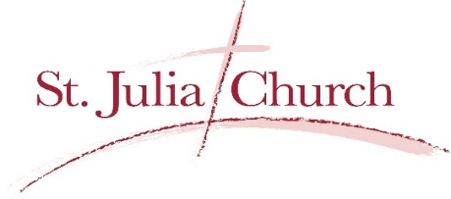

March 21, 2020
Navigating through COVID-19 Together with Christ as our Guide
My dear Sisters and Brothers,
Be not be afraid! It is hard to believe that we are not coming together as a parish family to celebrate Mass as all of our Sunday and weekday Masses have been cancelled until further notice. I want to assure you that I continue to offer Mass in our parish, now privately, for the needs of our parish, our community, our country, and our world. The Mass is the source and summit of our faith. As I have said, every time the Mass is offered, the entire church gathers around the altar. So, we are united together through prayer in the offering of the Mass. Yes, it is difficult not to gather as a community and to receive the real presence of Christ in communion, and so we are reminded, now more than ever, of our prayer of spiritual communion:
My Jesus, I believe that You are present in the Most Holy Sacrament. I love You above all things, and I desire to receive You into my soul. Since I cannot at this moment receive You sacramentallY, come at least spiritually into my heart. I embrace You as if You were already there and unite myself wholly to You. Never permit me to be separated from You. Amen.
We are reminded that Jesus is the prince of peace, and I pray that we experience the peace of Christ that only he can provide.
Additionally, all events and gatherings at our parish have been cancelled until further notice.
While our office is closed until further notice, we continue to be at your service. Please call our office at 905 684 5603 or email stjuliachurchstc@gmail.com. Phone and email messages will be checked on a regular basis. As always, you can email me directly at frgregoryschmidt@gmail.com. I encourage you to email your intentions or concerns which I can bring to our Lord at the altar.
As we have been advised, the best place for us to be right now is at home. This makes our website all the more powerful for keeping us connected. Visit us at www.stjuliastc.com. Here you will find links to the televised mass that you can watch from home, at any time. Also be sure to like us on Facebook (search St. Julia Roman Catholic Church) where you will find daily posts and the most up-to-date information.
In the midst of all of this, let’s continue to be united in prayer as we navigate through COVID-19 together with Christ as our guide.
May God continue to bless each of you and those that you love.
Fr. Greg Schmidt

